To jest przykładowy arkusz egzaminacyjny. Arkusz, który otrzymasz będzie wyglądał podobnie. Możesz na nim pisać i notować. Odpowiedzi musisz jednak zaznaczać na osobnej karcie egzaminacyjnej, gdyż tylko te będą brane pod uwagę. Po skończonym egzaminie nie wolno Ci wynieść arkusza egzaminacyjnego z sali, musisz go zostawić razem z kartą odpowiedzi u egzaminatora.
Egzamin rozpoczyna się częścią sprawdzająca umiejętność słuchania. Wysłuchasz nagrania dwukrotnie, z dwuminutowa przerwą. Przed pierwszym odtworzeniem nagrania będziesz miał/a dwie minuty aby zapoznać się z treścią pytań.
W przypadku ćwiczeń polegających na wybraniu prawidłowej odpowiedzi, tylko jedna z odpowiedzi jest poprawna.
W tym zestawie przykładowym zadanie pisemne polega na napisaniu ulotki opisującej zagadnienie medyczne. Na egzaminie możesz spotkać się także z innym typem pytania, polegającym na napisaniu odpowiedzi na list prywatny, który zawiera trzy pytania lub zagadnienia do skomentowania. Twoim zadaniem będzie odpowiedzieć na te trzy pytania lub opisać te trzy zagadnienia.

Listening Comprehension

Listen to the text and complete the notes. You will hear the text twice.

Frank supports the idea of genetically modified foods. He claims that such food is carefully …1…………………….…………….. . In his opinion it offers many different possibilities. For example, genetically modified food, such as …2………………………………………………. and …3………………………………………………………………………. may keep people healthier.

Ann distrusts genetically modified food mainly because she thinks it has not been …4………………………………………………… . She blames genetically modified food for causing …5……………………………………………. . She also says that by using modified food, food companies …6…….………………………………………………….poor countries. Ann is also worried about changes in …7…………………………………………………………….

Frank accuses Ann of being …8………………………………………………… . He claims that altered food will help animals which are becoming extinct, such as …9…………………………. .
Still, Ann does not like the idea of people being used …10……………………………………… .

Reading Comprehension

……1….. The first decade of the AIDS epidemic spawned a kind of hysteria, predominantly targeted at people living with HIV–AIDS, but also directed against the four high-risk groups: homosexuals, heroin addicts, hemophiliacs, and Haitians. There was an AIDS-quarantine ballot initiative in California, and various states threatened or passed conditional quarantine measures. Fortunately, such measures were used infrequently. Far more common then and now is the use of criminal law to target people who may have exposed their partners or others to HIV or transmitted the virus to them; between 2008 and 2013 alone, there were at least 180 such prosecutions.
Although there is not an Ebola epidemic in the United States, the first case of the disease in Dallas, the subsequent infections of health care workers there, and the case of a New York City–based doctor working with Médecins sans Frontières (MSF) have resulted in proposals for 21-day quarantines of health care workers returning from West Africa and other people coming to the United States from the region. …2……
AIDS activists have come out strongly against the quarantines in New York, New Jersey, and Connecticut, either in the press or in direct correspondence with the governors. The argument against these policies is based on the lack of scientific grounds for the quarantine criteria, the likelihood that unnecessary restrictions on those returning from the region will dissuade health care workers from volunteering to help fight the epidemic, the implicit and erroneous public health message sent by these quarantines that asymptomatic persons are a danger to their communities, and the inconsistency in applying the policies to health care workers who’ve had contact with patients with Ebola in Africa but not those who’ve seen patients in U.S. facilities.
…3…. Fighting epidemics requires national coordination and leadership, not ad hoc responses by 50 states pulling in different directions under the sway of partisan politics.
…4…..None of us would be alive today if it were not for their generosity and passion for their work and their willingness and even eagerness at the start of this plague to treat some of our country’s most marginalized populations, including gay men, drug users, and sex workers. This is a perfect moment for us to again show our thanks to the thousands of doctors and nurses who stood by us during the terrible early years of the AIDS epidemic. The least we can do now is to stand in solidarity with them as some politicians and journalists target them for opprobrium and discrimination and try to lock them up on baseless grounds.
…5…… We all have to become activists if we are to protect the public health from being used as a tool to serve primarily political purposes, as it has been over the past few weeks in the United States.

Adapted from: Panic, Paranoia, and Public Health — The AIDS Epidemic's Lessons for Ebola
Gregg Gonsalves, B.S., and Peter Staley
N Engl J Med 2014; 371:2348-2349 December 18, 2014
Available at: http://www.nejm.org/doi/full/10.1056/NEJMp1413425

Reading Task 1.
Choose the best ending for each sentence.

1. The author of this text claims that the states’ actions directed at medical staff dealing with Ebola
- is consistent throughout the whole country.
- is based on praiseworthy experience gained at the time when AIDS epidemic was being prevented.
- may make the fight with Ebola more difficult.

2. The New York City quarantine propodeal applies to
- all travelers coming from the Ebola-affected region.
- all health-care providers who have been working with Ebola patients.
- all people travelling from the region where Ebola occurs provided they suffer from symptoms of the disease.

3. The author’s strong resentment is not caused by the fact that quarantine measures
- are not based on medical evidence.
- are aimed at the medical workers, who have proved to be selfless and generous.
- are used by some politicians and newspapers to gain popularity.

4. There are reasons to believe that
- the author of the text is an AIDS activist.
- the quarantine will markedly prevent the number of new cases of Ebola in the USA.
- the epidemic of Ebola will spread across the USA.

5. At the beginning of the AIDS epidemic, HIV-positive American citizens were persecuted
- solely by imposition of a quarantine.
- as well as HIV-negative Americans from high-risk groups.
- by limiting their access to medical help.

Reading Task 2.
Five sentences have been removed from the text. Decide which sentence A-G belongs in each gap 1-5. There are two sentences too many.

- But another lesson from the AIDS epidemic is that we cannot let down our guard.
- History is repeating itself, as the irrational, punitive measures deployed in the AIDS epidemic 30 years ago are revived for another disease, this time a rare hemorrhagic fever responsible for only a few local cases.
- In addition, we believe that by rejecting scientific evidence, substituting unsubstantiated claims for facts, and undermining the credibility and authority of both the CDC and the National Institutes of Health, these quarantine protocols risk damaging our country's ability to respond quickly and efficiently to serious public health threats in the future.
- Prominent scientific and medical institutions have criticized state-based protocols that impose isolation and quarantine on asymptomatic health care workers and travelers, in contradiction to the CDC's protocol, and the overly broad application of these measures to people with no known contact with patients with Ebola.
- Those of us who are HIV-positive and have survived all these years owe a deep debt of gratitude to health care workers.
- Various politicians called for quarantining of anyone who tested positive for HIV, and commentator William F. Buckley infamously penned an op-ed in the New York Times saying that “everyone detected with AIDS should be tattooed.”
- Why has it been so easy, again and again, to slip into this kind of reaction to a public health issue, and why has it been so difficult for promoters of evidence-based practice to find remedies for it?

Reading Task 3
The following graph presents death rates in men and women in Scotland as compared to death rates in England and Wales. Decide whether the statements 1-5 are true, false or whether such information is not given. Write letters F, T and NG.

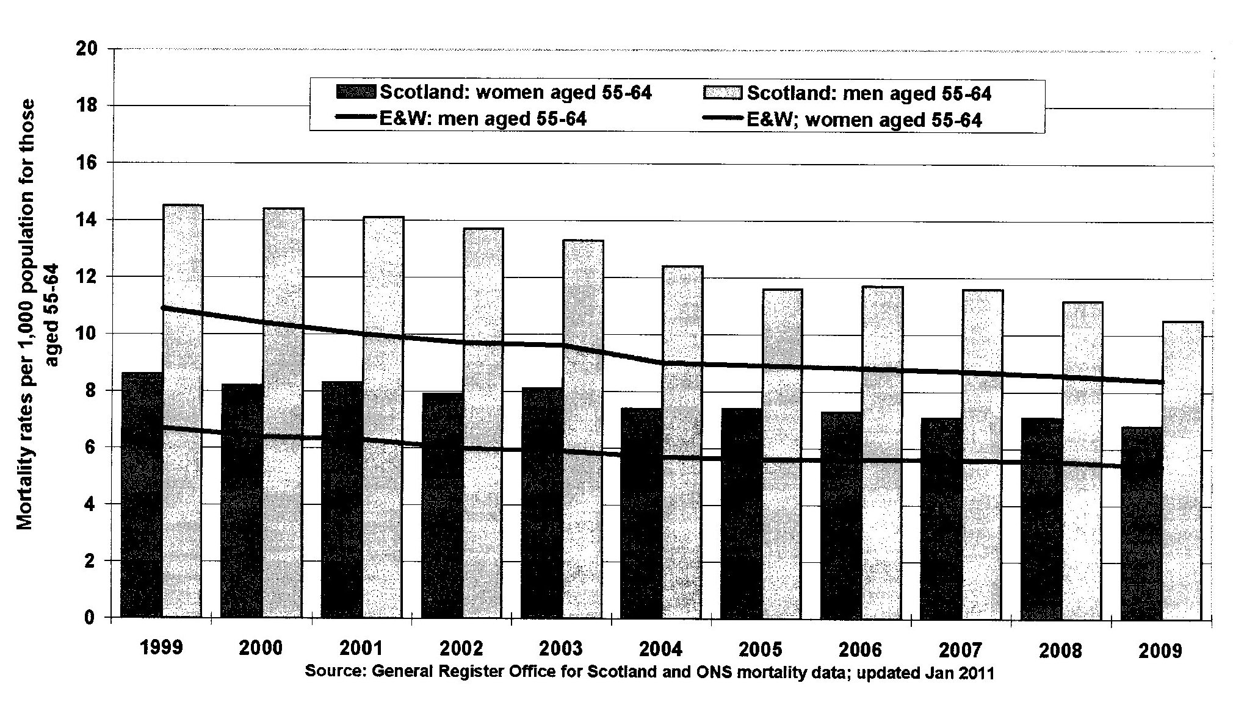
E&W women
E&W men

- The mortality rate among Scottish males aged 55-64 in Scotland in the period 1999-2009 decreased less rapidly than among English and Welsh women.
- The difference between the mortality among males and females aged 55-64 in Scotland in 2009 is just over three deaths per 1,000.
- A steady decrease in the death rate as presented in the table is caused only by the change in the male population.
- In the decade 1999-2009 the rate deaths among males aged 55-64 in Scotland was at least a quarter higher than in England.
- In 2009 the mortality rate for men in Scotland aged 55-64 approximated 1%.

Vocabulary

Task 1 – definitions - 5 pkt
Write definitions to the word given below:

blister ________________________________________________________
clinical sign ________________________________________________________
hysterectomy ________________________________________________________
menarche ________________________________________________________
metastasis ________________________________________________________

Task 2 – medical/colloquial terms – 5 pkt
Give medical and colloquial names of the following ideas:

difficulty or distress in breathing ___________________________________________________
a medication which relieves pain ________________________________________________________
the bony structure which runs through the trunk starting at the neck and finishing at the hips ________________________________________________________
an injury resulting in hemorrhage under unbroken skin ________________________________________________________
a sensation of spinning around ________________________________________________________

Task 3- adjectives - 3 pkt
Give adjectives related to these parts of the body (example: kidney-renal)

heart __________________________
eye __________________________
stomach __________________________
skin __________________________
navel __________________________
the peripheral parts (legs, feet, hands, etc.) __________________________

Task 4 – filling gaps – 5 pkt
Read the following text and fill the gaps with one suitable word.

A 70-year-old male patient was admitted from home …1… increasing breathlessness, orthopnoea and ankle oedema …2… the previous 3 weeks. His GP had …3… oral coamoxiclav and coamilofruse (substituting the latter for bendrofluazide). He had suffered …4… dyspepsia, increasing over recent weeks, and the general practitioner had noted a new murmur.
She was apyrexial yet tachypnoeic (25 beats min⁻¹); with a low volume pulse. Sitting blood pressure was 110/70 mm Hg. The apex …5… was in the anterior axillary line and a parasternal lift was prominent. A pansystolic murmur was audible and late inspiratory crackles were heard throughout both lung fields. There was sacral oedema.
The ECG …6… sinus tachycardia (110 beats min⁻¹) with antero-lateral Q waves of previous infarction and the chest X-ray confirmed cardiomegaly and interstitial oedema. Routine chemistry showed Na⁺ 128 mmol l⁻¹; K⁺ 5.8 mmol l⁻¹; urea 9 mmol l⁻¹; creatinine 155 mmol l⁻¹. A creatine kinase series was unremarkable. Echocardiography showed a dilated heart (left ventricular end diastolic distension (LVEDD) 650 mm) with anterior and septal hypokinesis and apical dilatation compatible …7… previous anterior infarction. The posterior wall was contracting vigorously. A high velocity jet (4.7 m s⁻¹) of mitral regurgitation was ……8… but the left atrial size was normal.
This is a common clinical …9… of progressive systolic dysfunction after unheralded myocardial infarction. Whereas in stable patients clinical identification or grading of the severity of heart failure is unreliable, recent …10… suggest that in acute heart failure clinical diagnosis is much more secure.
Br J Clin Pharmacol. 1999 Mar; 47(3): 239–247.
http://www.ncbi.nlm.nih.gov/pmc/articles/PMC2014219/

Task 5 - medical abbreviations - 5 pkt
Write in full what these abbreviations stand for:

CNS (central nervous system)
NAD (nothing abnormal detected)
c/o (complaining of)
DOA (dead on arrival)
FUO (fever of unknown origin)
HCT (hematocrit)
IV (intravenous)
L (left)
MCV (mean cell volume)
SQ (subcutaneous)

Writing
Write a leaflet for asthma patients explaining how to use avoid allergens. Divide the text in sections. Use language suited to your reader and full sentences. Include the following information. You may include more information. Your text should be 240-270 words long.

1. nadwrażliwość oskrzeli
2. objawy: kaszel, duszności, zmęczenie
3. przyczyna: reakcja na alergeny, kurz, roztocze, pierze, jedzenie
4. różne stopnie natężenia, łagodna, ciężka
5. leczenie; unikanie alergenów
6. ataki: zagrożenie życia
7. leczenie doraźne: leki wziewne, zawsze przy sobie
8. ważne: odpowiednia pozycja, odchylona głowa, głęboko oddychać
9. przy dobrym leczeniu: normalne życie
10. unikać nadopiekuńczości, wycofywania się z aktywności fizycznej

